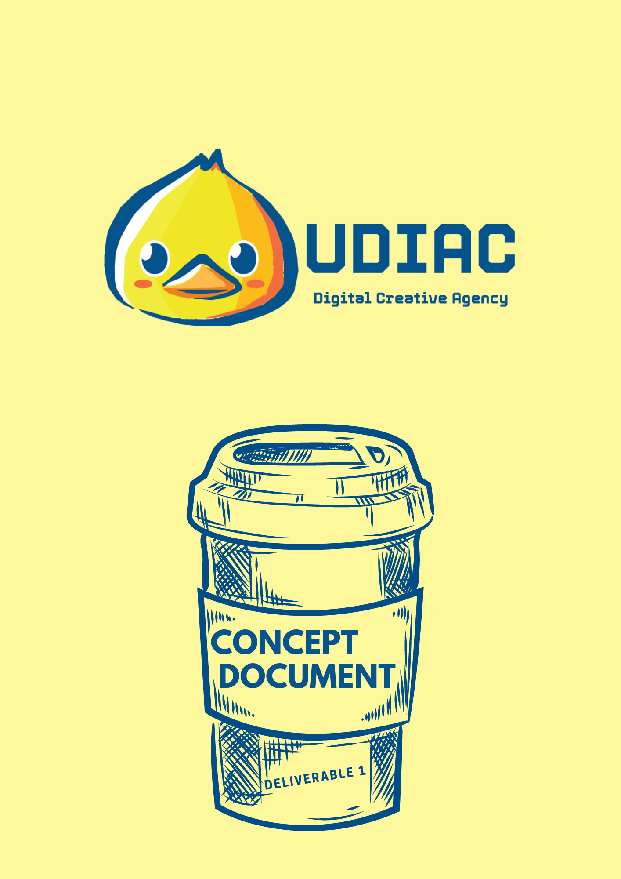

Concept document

Sprint 2 - Pitch

# Table of content

**Table of content** **2**

**Branding** **3**

**Companies that we discussed and the chosen one:** **8**

**Our concept and why?** **11**

**Target Group:** **12**

**Researches:** **13**

**Sprint 1** **13**

**Sprint 2 - until 15/10/2021:** **14**

**Design** **15**

**Sprint 3 - 17/10/2021:** **17**

Below you will read more about the branding of UDIAC Creative Digital Agency, the companies that we discussed, and of course the chosen one - LUCIFER COFFEE ROASTERS, more information about the process of the research and the target group you can find below. For more information about each research please have a look at the documents in the folder and “Deliverable 1” and “Researches we have conducted”.

[Deliverable 1](https://drive.google.com/drive/folders/1rjtuxRKW6HX-COPecaBZFbioLSpQcb2b?usp=sharing).

# Branding

Picking up the right name is not always easy, we started brainstorming and every member came up with different names and ideas. Finally, we agreed on using the first letter of our name, UDIAC is the chosen one, it's unique and more importantly, all the team members liked it.



For creating a strong, recognizable brand image we agreed to use a duck symbol in the logo.

The duck symbol makes customers smile and it is a break from the more ordinary logos for other agencies.



To make sure the duck is unique and suitable for the logo, we have analysed it with this website :

<https://logotester.thework.market/?main=no_bg_26646080208126762_main.png>

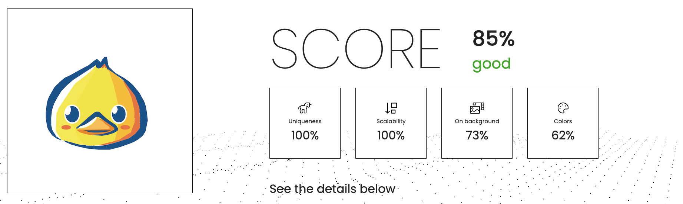

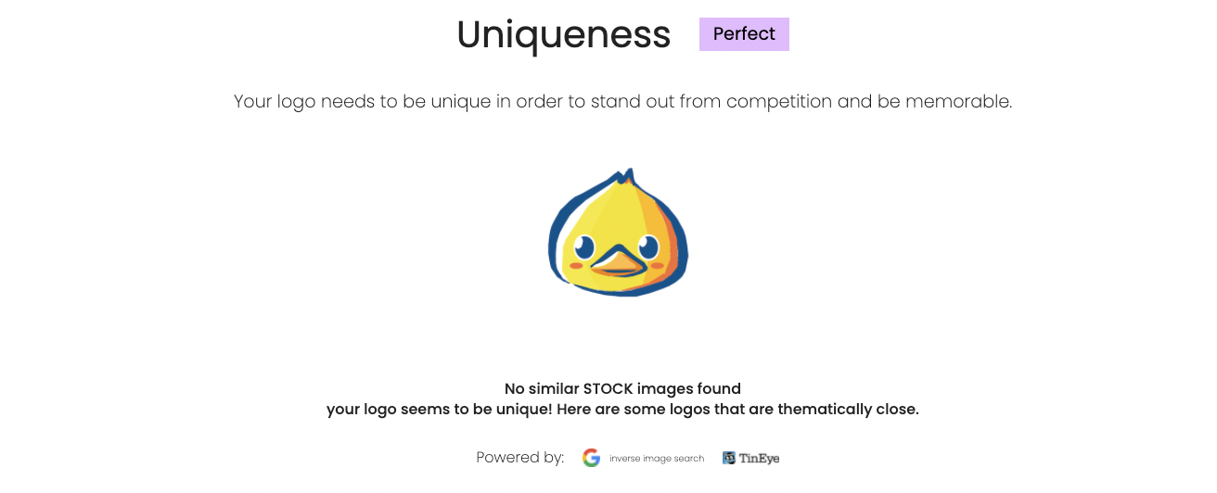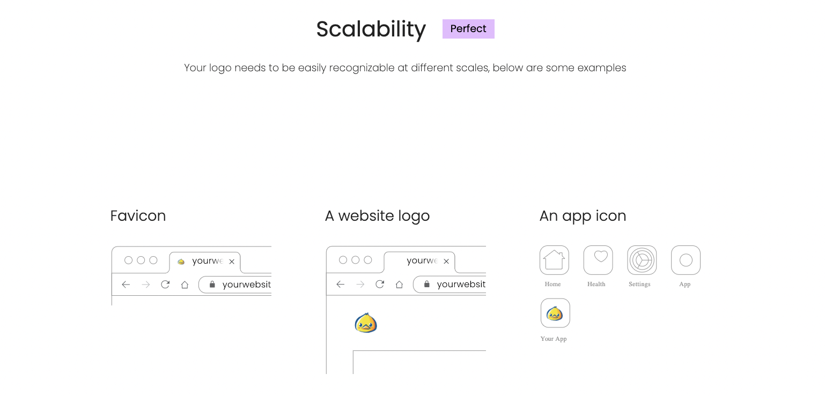

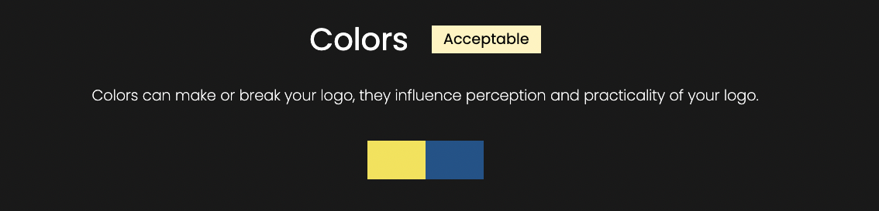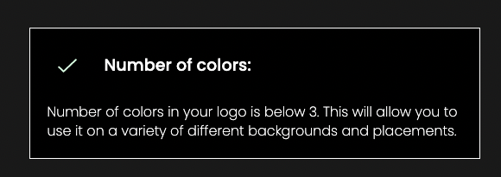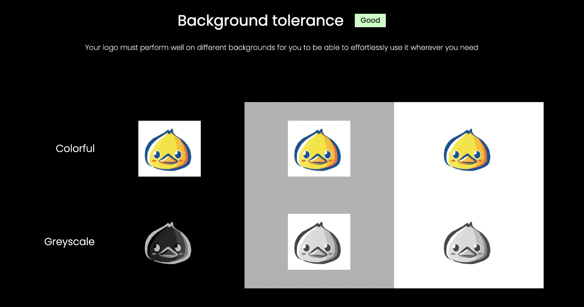

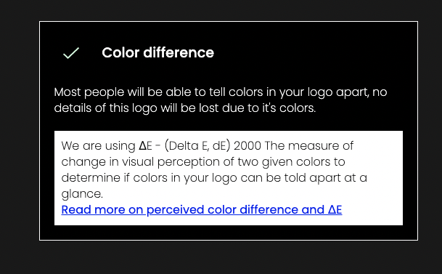

**Choosing the right logo**

During this step, we chose the best logo that would be the best example to describe our agency.

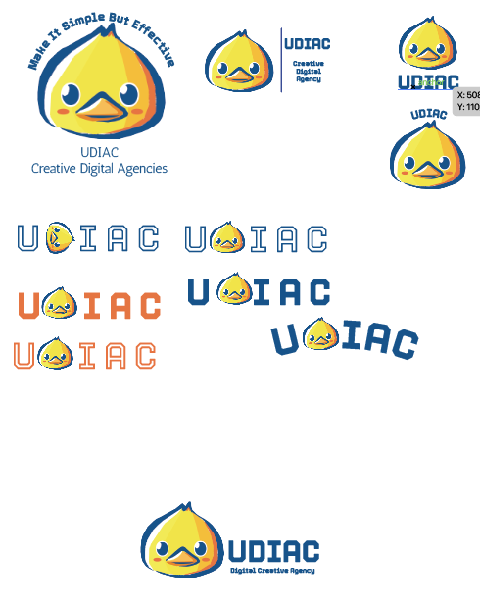

**Logo**

The imagery we want the customer to understand is funny and modern, we have chosen duck to give the customer a sense of joy and we have used UDIAC with Torney (bold) font to emphasize different aspects of the agency's modern look.



# Companies that we discussed and the *chosen* one:

In the beginning, all members worked on a shared mind map to collect as many ideas for companies as possible. Then we decided that each person on our team is going to come up with an idea for a company and make a presentation for it with their ideas for the challenges in the mind map. Then we presented them to each other and voted for our favorite choice. Umberto chose Too Good To Go, Desislava chose Starbucks, Ali chose Stadia, Iris chose the Body Shop and Catherine chose WizzAir.

**Umberto**

**Company: Too Good To Go**

It’s a free mobile application that connects restaurants and stores that have unsold, surplus food, with customers who can then buy whatever food the outlet considers surplus at a much lower price than normal.

**Purpose:** The purpose of Too Good to Go is to reduce food waste worldwide. The company claims this reduces the waste of food that would otherwise be discarded. Food waste is a global problem that affects the environment.

**Use:** The customer runs the TGTG app, which shows what outlets have what sort of food available within a certain radius and in a specified time slot, usually of 30 minutes or more. If any is selected the customer pays for it in a way compatible with the phone and collects within the time slot; the app's display confirming payment is shown, and the transaction is finalized by swiping the app to confirm collection.

**Desislava**

**Company: Starbucks**

Starbucks Corporation is an American multinational chain of coffeehouses and roastery reserves headquartered in Seattle, Washington.

**Purpose:** Their purpose is to establish Starbucks as the premier purveyor of the finest coffee in the world while maintaining their uncompromising principles as they grow.

Their principles are the following.

* Provide a great work environment and treat each other with respect and dignity.
* Embrace diversity as an essential component in the way we do business.
* Apply the highest standards of excellence to the purchasing, roasting, and fresh delivery of our coffee.
* Develop enthusiastically satisfied customers all the time.
* Contribute positively to our communities and our environment.
* Recognize that profitability is essential to our future success.

**Use:** Starbucks locations serve hot and cold drinks, whole-bean coffee, microground instant coffee, espresso, caffe latte, full and loose-leaf teas, juices, Frappuccino beverages, pastries, and snacks. Some offerings are seasonal or specific to the locality of the store. Depending on the country, most locations offer free Wi-Fi.

**Catherine**

**Company: Wizz Air**

Wizz Air is a Hungarian ultra-low-cost carrier with its head office in Budapest. Operates mainly all-around Europe.

**Purpose:** The purpose of Wizz air is to be an ultra-low-cost business, their work is centred around no-frills travel available for everyone, everywhere at the lowest price possible, creating equal value for all passengers while remaining conscious of the environmental responsibility we hold.

**Use:** You can book your flight through their website, mobile app, call centre and you can also book through travel agents and at most airport sales desks.

A travel itinerary will be sent to your email address, which includes:

* A unique confirmation code
* Flight number
* The date and time of travel
* Departure and destination details
* Full cost

For passengers booking flights via a travel agency or a third-party website, the itinerary will be provided by the travel agent. If the reservation was created not by you, any flight related changes will be communicated to the contact details of the booking owner.

**Ali**

**Company: Stadia**

Stadia is a cloud gaming service developed and operated by Google

**Purpose:** The purpose is to be capable of streaming video games to players up to 4K resolution at 60 frames per second with support for high-dynamic range (HDR) via the company's numerous data centres. It is accessible through Chromecast Ultra devices, the Google Chrome web browser on PC as well as other Chromium-based browsers, the Stadia mobile app on supported Android smartphones, and Chrome OS tablets.

**Use:** Stadia requires users to purchase games from its store to stream them. While the base service is otherwise free, a Pro tier monthly subscription allows users to stream in up to 4K resolution, 5.1 surround sound and offers a growing collection of free games that the user has access to while they are subscribed. Both tiers allow users to play online multiplayer without any additional costs. Stadia is integrated with YouTube, and its "state share" feature allows players to launch a supported game from a save state shared by another player via permalink. The service supports Google's proprietary Stadia game controller, along with various non-Stadia controllers through USB and Bluetooth connections.

**Iris**

**Company: The Body Shop**

The Body Shop International Limited, trading as The Body Shop, is a British cosmetic, skincare, and perfume company.

**Purpose:**  Sell ethically sourced, cruelty-free, and natural ingredients Products such as body butters /scrubs, hair care, cosmetics, face masks, etc.

They have campaigns to end animal testing.

**Use:** You can visit their shops and buy your desired products or order them online on their website.

**Final decision:**

The choice of the company was decided by the “dot method”. It’s easy to use to make decisions in big groups. Everyone's “voice” has an equal value. The result was“Starbucks”. With a later discussion and feedback from the teachers, we realised that Starbucks won’t benefit from a Loyalty program. So we brainstormed a bit more and came to the realisation, why not come up with a local place. We want to turn “Lucifer Coffee Roasters” into the next “Starbucks”.

# Our concept and why?

We, UDIAC Creative Digital Agency, will set out to completely overhaul Lucifer Loyal Program look and feel and create a unifying loyalty system called “Loyalties of Lucifer” that merges their goal and the needs of the customers. These innovations will help to achieve the goal, namely, to get as many Eindhoven residents as possible into specialty coffee – Eindje blend.

When joining the loyalty program, the loyal customers do challenges to gain “matchsticks” (points). When gaining enough matchsticks, they would be able to use them for rewards, such as discounts on coffee, merchandise, workshops, etc.

So let's take a brief look at the process of earning the matchsticks. The loyal customers enter the coffee place. They order certain items (coffee, sandwich, or something else), After they receive the receipt, they would be able to scan the QR code on it so they can see the points on their profile. Why QR? It contains all of the data for the points.

After earning enough points/ matchsticks, the loyal customers would be able to spend them on the reward page on the website. Depending on how many points they earned, there would be different rewards that the points could be spent on. When the customers have the points that they need, they can climb the reward of their choice. It will be stored in their profile. To use your reward you click on it. A timer of 1 minute would pop up and that had to be shown to the barista for confirmation. After the timer expires, this reward will disappear - the customer would be able to use it only once.

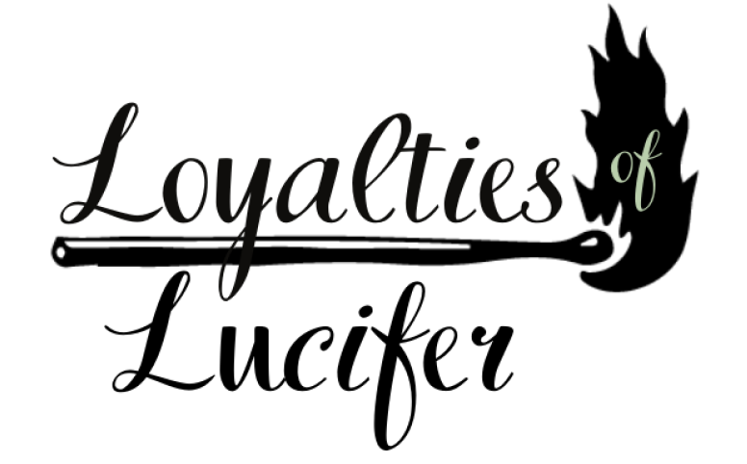

This Loyalty program “Loyalties of Lucifer “ would help attract customers by fulfilling the needs of every coffee consumer.

# Target Group:

Lucifer Coffee has three locations, only in Eindhoven. One of these locations is right outside Eindhoven Central Station, towards TU/e.We conducted interviews & observations at Lucifer Coffee Roasters at Kennedyplein 103 and Kleine Berg 47. We asked the waitress and clients questions so we can collect more data for the target audience.

Based on these answers, we can define the target audience a bit better.

One of the target audiences is businessmen/-women. They don’t have time to sit back with a cup of coffee but want to order and take it away, to go to work. They usually visit right before work or during lunch break and are in a rush, so they buy their coffee (or something else) for takeaway and leave to go to work. Another target group is students. They pass Lucifer when leaving the bus/train station, to go to TU/e or (depending on the location) Fontys.

For the location on Kleine Berg, it’s a different target group. Since Kleine Berg is a busy street with many restaurants, cafes, bars, shops, etc. many people come here. E.g. students come here to study and tourists or locals visit to take their time with some coffee/tea. When we went to observe, we noticed that it was mainly students sitting inside working. They even made sure that on one of the tables there was enough distance between each other.

**Conclusion:**

* The target group for the location Kennedyplein 103 is businessmen/women. This is because they work close by and pass it on their way to work and during lunch.
* Also, students going to/from TU/e are one of the target groups. They pass Lucifer on the way from the bus or train station.
* Furthermore, there is one more target group, the locals from the neighborhood. They like to visit the place and take some time to drink their coffee/tea.

The target group for the location Kleine Berg 47 is not final, but here we should focus more on the people that take their time to drink some coffee inside. We visited the location to observe but didn’t ask the baristas or customers any questions yet. For now, we would say the target group here is students since most of the people inside were younger people with their laptops.

# Researches:

# Sprint 1

**Primary research:**

1. Interviews & Observation

We quickly come to the realisation that there is not enough relevant information about Lucifer online to help us define the target group. That is why we decided to conduct observations and interviews directly from the “heart” of Lucifer because we thought that this would be the most efficient way to gather information. We interviewed the staff and a few clients. We limited the questions to 5 so we would not take much time from our interviews. The goal of the questions was to help us define the target group.

**Secondary research:**

1. Research - ***Literature review*** - articles, website, interviews (everything we could find)

Everyone's goal at the beginning was to get familiar with the coffee place Lucifer. What is Lucifer? Where is it? Why is their coffee so good? What makes them special? Basically to get to know the brand and find useful information that we can use.

***This method is called the “Literature review”.*** Usually at the beginning is a solid way to back up assumptions around your concept.

1. “Why” Lucifer?

We conducted this research so we could find out what is special about Lucifer. What is making it different from the other coffee shops?

1. Target group

We need to define the target group so it would be easy for us to create the Loyalty program for Lucifer. The target group will be based on the summary of all the collected data. This is something we still are working on. For now, we have some data and assumptions but they still need to be backed up with more information.

1. Competitor Analysis

By doing the competitor analysis we discovered some similarities and differences between our chosen company and their biggest competition. We can use them to our advantage in the loyal program so we can successfully attract more customers.

1. Branding

We got familiar with the look and feel of Lucifer, the origins of their name, font, colors . As well as some interesting facts that will be helpful for the advertisement. This data will be useful when creating the design for the user interface of the Loyalty program so we don’t lose their original characteristics.

*More data and information you can find in the documents for each research.*

Progress right now regarding the data we have :

We have a good start with data and information. However, the research needs to be conducted deeper so we can specify more details of our target group. We are in the process of arranging an interview with the manager to get more data. For now, we have some data and assumptions but they still need to be backed up with more information.

# Sprint 2 - until 15/10/2021:

*More data and information you can find by clicking on each research!*

1. [Survey](https://drive.google.com/drive/folders/1iO4m_ITldVrSZuQGzunvnriWO91jraBw?usp=sharing)

We created the survey, so we could collect more data about the target audience and use it for design ideas. This survey helped us back up assumptions from our previous research.

1. [Interviews](https://drive.google.com/drive/folders/1Z2QEplHjk899x6YKbqcAbhhWXQ2-PbYh?usp=sharing)

We conducted an interview with the manager of Lucifer roasters to get his feedback and inside of our concept. We as well managed to arrange two interviews with the “businessmen” target group and interviewed four people from the “student” target group. We had an interview with the staff and a client during sprint 1. Which now we can analyze is from the student target group.

1. [Personas](https://drive.google.com/drive/folders/1mGMQK51hbZoVyBCcE7jWzSfJZGUfEnh8?usp=sharing)

We created two personas - the businessmen and the student based on the data we collected from all the research. We chose to work on those two, because of the survey and the interview, we collected more data than for the locals.

1. [User Scenarios](https://drive.google.com/drive/folders/1pU3_rNbb-oj-tCLQgTIoOqAa4McayNiR?usp=sharing)

By creating the user scenarios we got a brief inside of the steps the user needs to take to get to his goal. We put ourselves in their mindset and got a better understanding of the steps they will need to do to achieve their desire.

1. [Customer journey](https://drive.google.com/drive/folders/1T9OX7GBtq2NoqRVMYaMZrCxmUg_EfviP?usp=sharing)

After we created the personas and user scenarios, we created two customer journeys (for the businessmen and the students) to get some insights into what the customers might go through.

1. Storyline

Loyalties of Lucifer is “Lucifer Coffee Roasters’” loyalty program. We created a Loyalty program for this company, because we want to help them grow. When joining the loyalty program, loyal customers do challenges to gain “matchsticks” (points). When gaining enough matchsticks, they can use them for rewards, such as discounts on coffee, merchandise, workshops, etc.

1. [POV & HMV](https://docs.google.com/document/d/11x2freMRLmGKd1IRoJFXrn4ZhQIuFvSszI9IWEOEtX0/edit?usp=sharing)

# Design

Our team created a design of the Loyalty program similar to the website of Lucifer Coffee Roasters so we could keep the same look and feel. Our main flow of colour is green #B9CEAC is based on the design of Lucifer. The same goes for the choice of fonts (Bebas Neue) and other colours. We kept the structure of the navigation similar to Lucifer’s website.

Bebas Neue - main font:



Colors



#B9 CEAC #000000 # D7B997 #7E0000

Matchsticks (points)

Every team member had to come up with a name for our points. Our top two were coffee beans vs matches . Our final choice was the icon of the match. One of the reasons was that Lucifer already uses stamp cards for collecting “matches”.We decided to keep that choice as well. Click on [brainstorming names](https://docs.google.com/document/d/1brktVSNX7iURc7tjYzSk8MvnOvk0wELjk6v0Gp-2jv8/edit?usp=sharing) to take a look at our previous ideas for names.

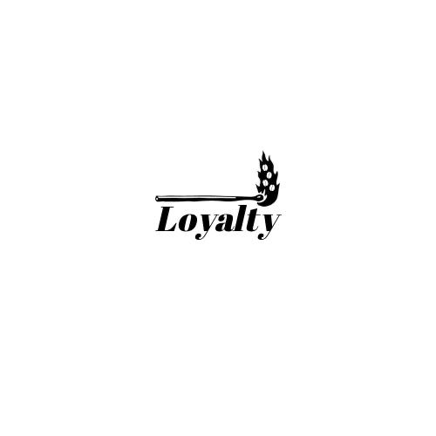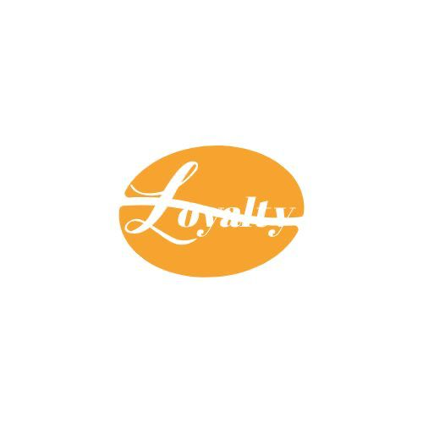

Previous versions/test logos

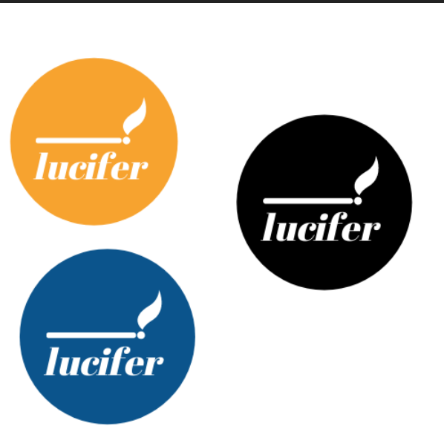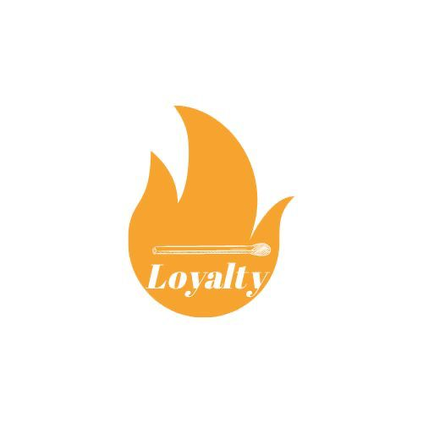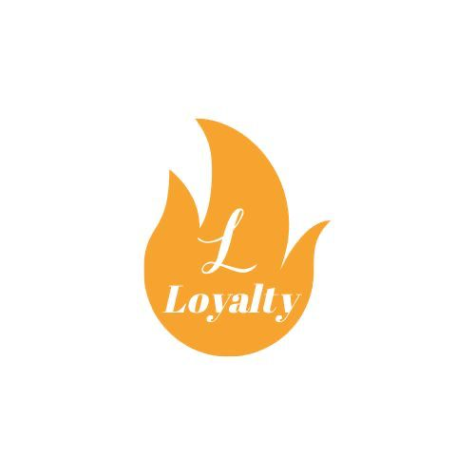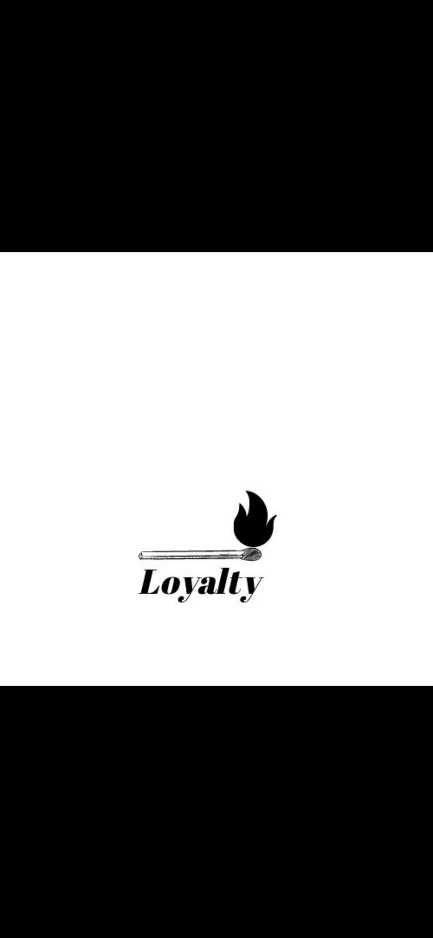

A mistake we made in the previous logos was not having our name in the logo. It said loyalty but loyalty of what? It was unclear. Dutch people know a lucifer is a matchstick. But other people who don’t speak/understand Dutch, don’t know what Lucifer is. So for example they would see “Matchstick loyalty” or “Loyalty matchstick”. This was very confusing, so we decided to put our full name as our logo. The final logo matches the aesthetic of Lucifer Coffee Roasters.

Final Logo of “Loyalties of Lucifer”



We started with demo [wireframes](https://drive.google.com/drive/folders/1LTSW4TRpDRCqNpJZm6rxqekkfWZ8D-MD?usp=sharing) and [mock-ups](https://drive.google.com/drive/folders/1Kf9cZDG-jBf04bZV3Jh59wQBudoZsNDg?usp=sharing). We created a structure and each teammate had to come up with a design. We voted for the things we liked and kept updating the wireframes and mock-ups. We asked for feedback from our classmates and friends on which design they liked more. Most of them as well as our teammates liked the design Ali created.

From there we started building on it to improve it. One of the things we worried about was that it was starting to look a bit like Starbucks' website because it was one of our inspirations.

We quickly fixed it and improved the structure so it should be unique. The design on all pages is following a guideline of white-green-white. Another thing we fixed was the scale of the different pages. Because different people were building different pages the scale was kinda off. We made sure all the sizes are the same.

We thought about the usability of the website. One of the things we removed was the search bar from our first versions of our mock-ups because we realised that even though it is a nice thing to have we do not really need it.

In the [prototype](https://www.figma.com/file/TgFL74ByoTN9WGcxxxt751/Untitled?node-id=4%3A281), you can see our final version.

1. [Business model](https://docs.google.com/document/d/1xCVJHVbaZE0jdmH10rssUGlU3n0PZEY4/edit?usp=sharing&ouid=104034465236787239144&rtpof=true&sd=true)
2. [Video prototype](https://drive.google.com/file/d/1Pha6VoZepratFrqXW1-yMIsLk9gvp2OI/view?usp=sharing)
3. [Testing of prototype](https://drive.google.com/drive/folders/1GAprmd_piNf64Iptdfn2rf2WWEAdTPQt?usp=sharing) (Task analysis).

We testested the prototype and received feedback on how to improve it. We implemented the changes and tested it again. We conducted *5 seconds tests* and *task analysis* of 3 scenarios.Then we had four post-taks questions to get more information.

1. [Blog](https://udiac.tumblr.com/)

Progress right now regarding the data we have (15/10/2021):

Assumptions and data backed up successfully of the researches we conducted.

# Sprint 3 - 17/10/2021:

*More data and information you can find by clicking on each research!*

**Primary research:**

1. [Interviews](https://docs.google.com/document/d/1SrLTaa2hLvyxGaRaFXaIxWER3anoCzOqPUWGS5ocyzg/edit?usp=sharing)
2. [Concept Testing Survey](https://docs.google.com/forms/d/1Ob3LAU84XnXy9gFIxFveys2o6App0Z1yQ7t2iHHMVf8/edit?usp=sharing)
3. [CMD Methods](https://drive.google.com/file/d/1pi_dkzCswse5FihWL9hAQotQ1YAYwOfL/view?usp=sharing)
4. [MoSCoW Analysis](https://drive.google.com/file/d/1UukzPW55-OsnnIZjESitMS-NsWP1HHtq/view?usp=sharing)
5. [Test Report - Website](https://docs.google.com/document/d/1gu28Oc8zuulgxjqmWt89c1nArSCjjbN0fHxUqRQkGeI/edit?usp=sharing)
6. [NFC - testing](https://docs.google.com/document/d/1Yy_jkJ8b5TrBqIBwfZ4yFbYL3AKcKe6XpX_4mBxgXw4/edit?usp=sharing)
7. [Design of website survey](https://docs.google.com/forms/d/1sWJNfy6P3-BAd2vYP55CfTgwWZF0du7d81QT1HlTFg8/edit?usp=sharing)

What’s new:

1. [Storytelling](https://docs.google.com/document/d/1L9mkY1T8ygK3r_Lc4BcQAEoplkzGgadLWIoW7V7ZFB8/edit?usp=sharing)
2. From QR code to NFC tag - Why and how you can find more information in detail by clicking on the link

Journey:

Setting up git and getting introduced to the commands.